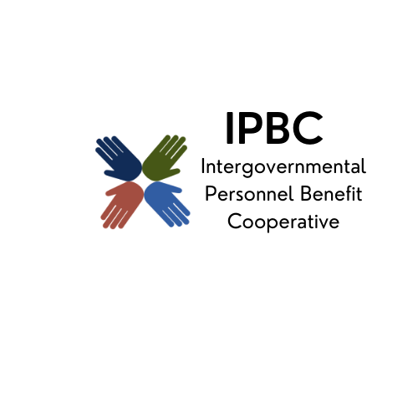
The premier health benefit option for Illinois local governments

Executive Board Meeting Agenda
July 17, 2025, 1:30 pm
Join the meeting now
Meeting ID: 287 726 238 878 9
Passcode: TY2VC23j

Dial in by phone
+1 323-792-6282,,490973516# United States, Los Angeles
Find a local number
Phone conference ID: 490 973 516#

- Call to Order
Page
- Consent Agenda (Attachment 1)
  - Approval of Remote Participation
  - Minutes of May 15, 2025
  - Vendor Checks for period of May 15, 2025, to July 2, 2025

- Officer Reports
  - Chair
    - Task Force Membership for Review of Benefit Consulting Options
  - Vice-Chair
  - Treasurer

- Action Items
  - Amendment to the Administrative Services Agreement Between the IPBC and RPA
  - Membership of the Village of Bethalto
  - ESI Coverage for GLP-1 Diabetes Management
  - Approval of Vicarious Multimedia Agreement
  - 2026 Meeting Calander

- Discussion/Information Items
  - Strategic Plan Update
  - Possible Programs to Review
  - Medicare Continuation Coverage Implementation Update
  - Medical and Pharmacy Trend Reports
  - June 2025 Preliminary Financial Reports
  - IPBC Marketing Report

- New Business

- Old Business

- Confirmation of Next Meeting – September 25, 2025, 9:30 am

- Adjournment

