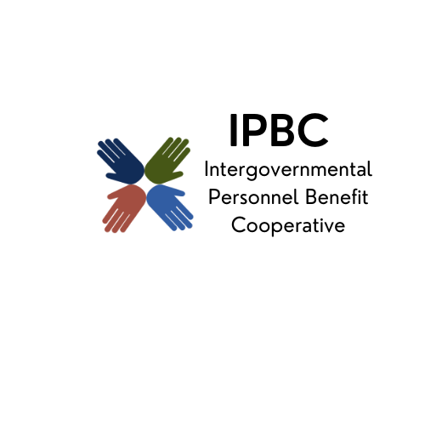
The premier health benefit option for Illinois local governments

Operations Committee Meeting Agenda
July 10, 2025 9:30 am
Join the meeting now
Meeting ID: 274 161 271 755 3
Passcode: Pe2nk97C
Dial in by phone
+1 323-792-6282,,382181509# United States, Los Angeles
Find a local number
Phone conference ID: 382 181 509#

- Call to Order Page

- Action Items
  - Approval of Remote Participation
  - Minutes of March 6, 2025
  - ESI Coverage Options for GLP-1 Diabetes Management
  - Vicarious Multimedia Proposal

- Discussion/Information Items
  - Possible Programs to Review
  - Medicare Continuation Coverage Implementation Update
  - Medical and Pharmacy Trend Reports
  - May 2025 Monthly Financial Reports
  - IPBC Marketing Report

- Old Business

- New Business

- Confirmation of Next Meeting –

- Adjournment

