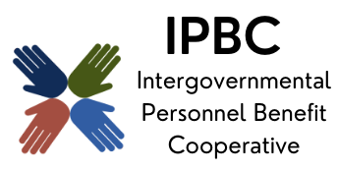
The premier health benefit option for Illinois local governments

MEMBERSHIP MEETING AGENDA
TEAMS
April 2, 2026, 9:30 am
Teams
https://teams.microsoft.com/meet/28890997505530?
p=CtvWoO7k7VbxAAlsw1
Meeting ID: 288 909 975 055 30
Passcode: QM2eH6er
Dial in by phone
+1 323-792-6282,,33539333# United States, Los Angeles
Find a local number
Phone conference ID: 335 393 33#

- Call to Order

- Marketing Process
  - Level of interest in joining IPBC
  - Possibility of members leaving because of renewal
  - Pool impacts when a member leaves

- Communications Update
  - The change to RPA and impact to our model for adding staff

- Training
  - New members, communicating onboarding or basic 101 training
(Attachments sample email, introduction to IPBC, Member responsibilities)
  - Website Update

- Confirmation of Next Meeting – August 27, 2026

- Adjournment

