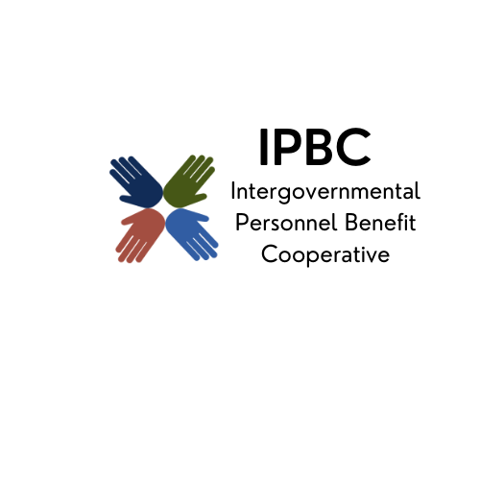

The premier health benefit option for Illinois local governments

Finance Committee Meeting Agenda
September 11, 2025, 9:00 AM
Teams
Join the meeting now
Meeting ID: 278 166 689 664 3
Passcode: bK94AK2Y

Dial in by phone
+1 323-792-6282,,342498706# United States, Los Angeles
Find a local number
Phone conference ID: 342 498 706#

- Call to Order Page #
- Action Items
  - Approval of Remote Participation
  - Minutes of February 12, 2025
  - Possible Renewal Assumption Changes
  - Amendment #1 to Consulting Services Agreement between
Milliman, Inc. and the IPBC
  - Consideration of Modifying the IPBC Investment Strategy & Guidelines
  - Revised Financial and Administrative Policy & Procedures

- Discussion/Information Items
  - Medical & PBM Claim Audit Updates
  - FY 2024-25 Preliminary Financial Results
  - July 2025 Monthly Financial Reports
  - Cash & Investments as of July 31, 2025

- Old Business
- New Business
- Confirmation of Next Meeting – November 6, 2025, 9:30 am
- Adjournment

