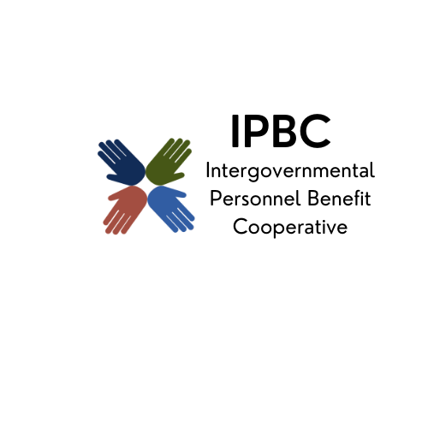
The premier health benefit option for Illinois local governments

Operations Committee Meeting Agenda
September 9, 2025, 9:30 am
Teams
Join the meeting now
Meeting ID: 210 299 087 888 3
Passcode: Du9r2Lj3

Dial in by phone
+1 323-792-6282,,383202188# United States, Los Angeles
Find a local number
Phone conference ID: 383 202 188#

- Call to Order

- Action Items
  - Approval of Remote Participation
  - Minutes of July 10, 2025
  - Revised New Member Policy
- Discussion/Information Items
  - Medicare Continuation Implementation Update
  - PlanSource Contract Renewal
  - Cancer Advocacy Services
  - Wellness Results
- Old Business

- New Business

- Confirmation of Next Meeting – November 4, 2025, 9:30 am

- Adjournment

